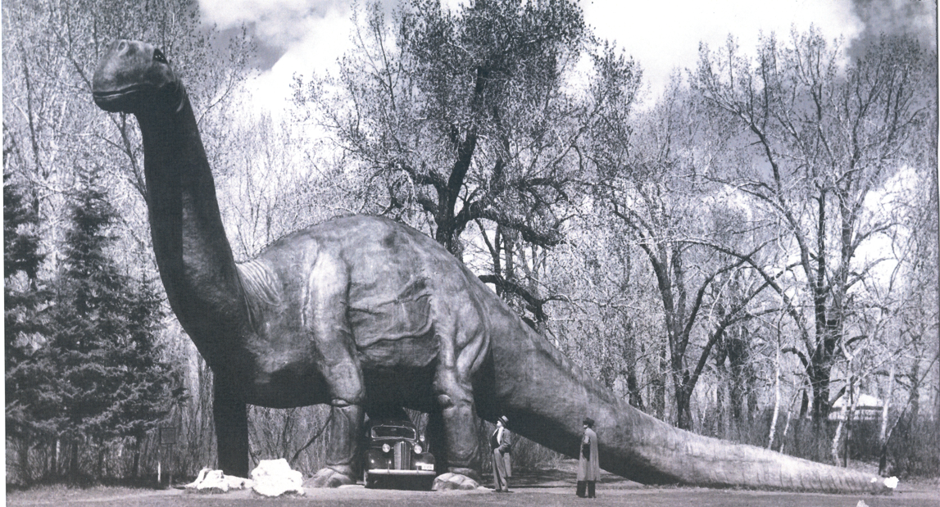

Dinosaurs in the Archives

The City of Calgary Archives has a wide variety of records about the arrival of the dinosaurs at the Calgary Zoo. Take a look at the records in the box to find the answers to the questions below…

- What date was the Natural History Park on St. George’s Island formally donated by the Calgary Zoological Society to The City of Calgary?
___________________________________________________________________________________________
- Where did the idea to create a Dinosaur Garden come from? Why was the construction of this idea delayed until 1936?
___________________________________________________________________________________________
- How much money was approved by City Council for the development of the Dinosaur Garden? Why was construction delayed until 1936?
___________________________________________________________________________________________
- How much was the builder paid to build the dinosaurs in 1935? Who were his helpers?
___________________________________________________________________________________________
- What troubles did they experience when building the dinosaurs? What did they do to correct the problem? Do you think that this worked?
___________________________________________________________________________________________
- What were the first three dinosaurs to be built? Can you find photos of these dinosaurs? Do you think that these models would be considered accurate today?
___________________________________________________________________________________________

- How much does “Dinny” the dinosaur weigh? Is he hollow in the middle?
___________________________________________________________________________________________
- Who created most of the dinosaurs? Who recommended that he be acknowledged at the Calgary Zoo?
___________________________________________________________________________________________
- Which dinosaur was known as the “Thunder Lizard”? How did the “Thunder Lizard’s” environment protect it from predators?
___________________________________________________________________________________________
- What are the time periods and animals represented in the No. 1 Fossil House?
___________________________________________________________________________________________
- How did the builders know what the dinosaurs looked like when all we had to work from was bones?
___________________________________________________________________________________________
- When did “Dinny” become the Calgary Zoo’s official mascot?
___________________________________________________________________________________________
- Why did Dinny need to be fixed in 2021? How much did this cost? Why did they create a “mini Dinny”?
___________________________________________________________________________________________
___________________________________________________________________________________________
- Which dinosaur was the most photographed thing in Calgary for many years?
___________________________________________________________________________________________
- Have you noticed that there are number of conflicting dates for when Dinny was created, how much he weighs and whether or not he was the first dinosaur to be built?? Which sources do you think are most reliable for this information? Why?
___________________________________________________________________________________________
___________________________________________________________________________________________
___________________________________________________________________________________________

