

DOCUMENT CHECKLIST to accompany your Purchaser Application Form:
*To be considered, a submission must be complete and include the following:

Completed Purchaser Application Form
In order to properly assess the purchaser’s application, we require as much detail as possible at this time. Please provide the following information with your application:

- Relevant Industry Experience – Provide examples of past and relevant current projects. Provide commentary on how these examples are similar and demonstrate relevant experience. Indicate Developer’s tiering status for development agreements.
- Schedule – Provide a proposed project schedule. Include high level milestones such as development permit, building permit, construction start and occupancy. Include the planned project team to demonstrate ability to deliver and any current projects which will be underway during this proposed project schedule.
- Proposed Development: Provide a brief description of the proposed development (inclusion of concept plans/renderings, and other supporting materials are encouraged). Include details such as the proposed mix of housing, commercial, etc. (type and tenure including below market housing options if applicable).
- Proof of funds to close and complete development (letter of support from a qualified, reputable financial institution).

Letter from the purchaser acknowledging licensed broker/associate representation (if applicable)

Evaluation of applications will be based on purchase price offered together with the required information regarding the purchaser's experience, financial capacity, proposed development, development schedule, and overall ability to deliver the project. The City of Calgary is seeking purchasers who demonstrate the capability and commitment to proceed with development within the timelines proposed in their submission.
Each submission will be judged on its own merits with consideration as to, but not limited to, the economic, social, financial and environmental implications return to the City as well as the closing conditions. The highest offer may not necessarily be recommended for acceptance or accepted. The City reserves the right to abandon this offering without accepting any of the submissions.

Please submit your completed Purchaser Application Form to:

Nagib Mohamed
Sales Agent
The City of Calgary - Real Estate & Development Services
nagibali.mohamed@calgary.ca
Phone: (368) 995-4462

Nitin Agarwal
Senior Sales Agent
The City of Calgary - Real Estate & Development Services
nitin.agarwal@calgary.ca
Phone: (368) 368-887-1264



Please complete this form if you are interested in purchasing land from The City of Calgary. The information you provide is not an offer or a contract and does not constitute an interest in land. The purpose of this form is to provide information to The City of Calgary regarding a desire to purchase a property. The completion and tendering of the form in no way obligates the applicant to purchase the property in question and is not in any way binding upon The City of Calgary. It is for information purposes only.

Real Estate & Development Services will review the form and contact you to confirm whether or not The City of Calgary will consider your application for negotiation. The City of Calgary reserves the right to negotiate with only those parties it determines, in its sole discretion. The City of Calgary reserves the right to amend or abandon any property listing without accepting any Purchaser Application Form. Purchasers may submit offers on one parcel, multiple parcels, or all available parcels. Each parcel or combination of parcels should be clearly identified within the submission.

PROPERTY REQUESTED

Property: | Indicate your offer price for each parcel of interest. If you are not submitting an offer on a particular parcel, leave its pricing fields blank.
Block 36, Lot 1 (1.43 acre)
Block 36, Lot 2 (1.5 acre)
Block 38, Lot 1 (2.5 acre)
Block 4, Lots 13-44 (1.63 acre)
Total Purchase Price Offered*
CONTACT INFORMATION
Purchaser’s Name*
that is to appear on title
Contact Person*
Phone Number*
Fax Number
E-mail Address*
Address
City
Province/State
Postal/Zip Code
GST Registration No. *
GST is the responsibility of the purchaser
* indicates a required field

LAWYER INFORMATION

Name and Firm
Phone Number
Fax Number
E-mail Address
Address
City
Province/State
Postal/Zip Code

LICENSED BROKER / ASSOCIATE (IF APPLICABLE)
If using a licensed broker/associate, all negotiations must take place through them. Licensed brokers/associates involved in the transaction that are directors or shareholders of the company purchasing the property will not receive a referral or finder’s fee. Please refer to the FAQs on http://www.calgary.ca/CS/realestate/Pages/Finders-Fee.aspx for finder’s fee structure and information on when fees are payable.

Associate’s Name and Brokerage*
Associate’s Phone Number*
Associate’s Fax Number
Associate’s E-Mail*

Where did you hear about this listing?* | Other:
Associate / realtor Calgary.ca/realestate  Industry mailout Dispatch newsletter  Direct mail Social Media  Online search Roadway sign | Other:
* indicates a required field

The proposed corporation that is to hold title to the property must be either a corporation incorporated in Alberta or a corporation extra-provincially registered in Alberta. The ability to change the corporation that is to hold title should be made prior to the expiry of the due diligence period. After the due diligence period changes to a corporate entity would be permitted at the City’s sole discretion.

Signature: Date:
This information is collected under the authority of section 33 (c) of the Freedom of Information and Protection of Privacy Act
and for the purpose of property sale transactions with The City of Calgary.
It is protected by the privacy provisions of the Freedom of Information and Protection of Privacy Act.

TERMS AND CONDITIONS (more detailed terms and conditions will accompany a proposal letter)

Closing Date/Possession/Adjustment Date:

(i.) Sixty (60) days following waiver of the due diligence condition or as agreed to between the vendor and purchaser.

Conditions Precedent:

(i.) The purchaser shall have sixty (60) days to conduct its due diligence. This condition must be waived or satisfied in writing.

(ii.) If requested by the Vendor, the Purchaser shall provide confirmation that it is in possession of, or has arranged for, the funds necessary to complete the proposed development (as evidenced by the executed equity and/or debt commitment letters from one or more reputable financial institutions on or before sixty (60) days prior to the Closing Date.

Special Terms and Conditions:

  - The sale will be subject to a building commitment for the development on the Property. The building commitment may be based on a commitment to achieve a certain level of construction (ie parkade level to grade) or expenditure of a percentage of the total project costs by a set date. To secure the satisfaction of the building commitment, the Purchaser may either grant an option to repurchase to the Vendor or pay a performance deposit. Specific terms will be negotiated between the Purchaser and the Vendor.

  - The Purchaser, at its sole cost and expense, to be responsible for all service connections and driveway crossings, subject to The City and Real Estate & Development Services' engineering and servicing requirements, as set out in Attachment 1. The Purchaser shall pay a damage deposit fee of $50,000 per lot on the Closing Date.

  - The Property is sold on an "as is" basis and the Purchaser is purchasing the Property at its own risk and shall assume all responsibility and liability, including, without limitation, any environmental matters existing as of the Closing Date. The Vendor provides no representation or warranty in regards to the presence or absence of any environmental contamination or hazardous substances.

  - The vendor to pay a finder's fee only upon closing as follows (subject to change):

Purchase Price | Finders Fee  % Rate | Minimum | Maximum
$0-$1,000,000 | 2.50% | None | $25,000
$1,000,001-$5,000,000 | 2.00% | $25,000 | $100,000
$5,000,001-$10,000,000 | 1.50% | $100,000 | $150,000
$10,000,001+ | 1.00% | $150,000 | $250,000

  - All encumbrances currently appearing on title to the property shall remain on title as permitted encumbrances for the original sale of the lands.

  - The Purchaser shall not assign its interest in the Property without the prior written consent of the Vendor, acting reasonably. If the Vendor consents, the Purchaser and the assignee shall enter into an assignment and assumption agreement in a form satisfactory to the Vendor’s solicitor, acting reasonably. Notwithstanding the foregoing, the Purchaser shall be entitled, without the consent of the Vendor, to assign its interest in the Property to an affiliated or related entity that is majority-owned by the Purchaser.

  - Any assignments, amendments, or extensions to the transaction (including the building commitment) or should the Vendor exercise its rights to repurchase Property are subject to the imposition of an Administration fee commensurate with the work required to be done. Should the Vendor exercise its right to repurchase (if applicable) the Property, the Purchaser shall pay an Administration fee of 15% to be deducted from the purchase price.
  - Any additional terms and conditions may be agreed between the parties.

APPLICANT: PLEASE STATE ANY FURTHER TERMS AND CONDITIONS YOU WOULD LIKE US TO CONSIDER:



REAL ESTATE & DEVELOPMENT SERVICES
RIVERBEND TOD ENGINEERING & SERVICING REQUIREMENTS

PURCHASER’S RESPONSIBILITIES & REQUIREMENTS
- Lot Grading and Storm Drainage

  - The Purchaser must contact their RE&DS sales agent for detailed information on lot grading and storm drainage criteria for Riverbend TOD.
  - All lots are designed on a lot by lot basis. RE&DS does not represent or warrant that the existing grades on the Purchaser’s lot, or the grades as they exist at closing, meet the applicable grade requirements.

  - The Purchaser shall, at its sole cost and expense, ensure that:

    - the Purchaser’s development meets the minimum floor slab grade for Riverbend TOD and that it complies with the requirements of The City of Calgary Lot Grading Bylaw 32M2004, as may be amended from time to time; and

    - the grade elevations at the property lines of the Purchaser's lot match the finished lot property line grade approved for Riverbend TOD, unless the Purchaser has obtained approval for grade elevations that match any previously approved and/or finished grades on adjacent lots.
  - If the Purchaser wants to change the grade elevations at the property lines of the Purchaser’s lot, the Purchaser shall obtain the consent of RE&DS. RE&DS will not unreasonably object provided the Purchaser’s proposed changes:
    - do not conflict with RE&DS’ obligations as developer within Riverbend TOD;
    - do not impair the original design of onsite storm water drainage and storage for Riverbend TOD;
    - have been agreed to by all adjoining land owners; and
    - are approved by the Approving Authority (where “Approving Authority” means a person or body appointed as the development authority or subdivision authority of The City of Calgary under Part 17 of the Municipal Government Act (Alberta)).

  - If there is a grade elevation difference along the property line that has been pre-approved by RE&DS, the Purchaser will be obligated to either build a retaining wall or provide for backsloping within its lot to provide the necessary support for the grade elevation difference. All grade elevation differences are subject to the review and approval by the Approving Authority.
  - If, at any time, there are drainage issues or concerns within Riverbend TOD, RE&DS may require the Purchaser to modify the grade on its lot to address such drainage issues or concerns.

  - If any lot owner changes the grade on its lot and such change in grade results in a cost to RE&DS (for example, for having to modify grades elsewhere within Riverbend TOD to

compensate), RE&DS will seek recovery of such costs directly from the offending lot owner, without prejudice to any other rights and remedies available to RE&DS in law.
  - Concrete and grass drainage swales assist with grade control in some locations and cannot be altered or removed by the Purchaser.

  - If the Purchaser consolidates or subdivides its lot, the final grades of the newly consolidated or subdivided lot(s) must conform to the above-mentioned lot grading requirements. The Purchaser shall be solely responsible for any and all risks, losses, liabilities, negative impacts and costs associated with the consolidation or subdivision of its lot, including, but not limited to, all expenses associated with having to re-grade to meet the specified requirements.
- Fees & Invoicing

  - The Purchaser is responsible, at its sole cost and expense, for:

    - the cost of tie ins to storm, sanitary, and water in the road right of way (the “Service Connections”) from the main lines in the road right of way to any building(s) or other location on the Purchaser's lot (to be arranged by and completed by the Purchaser at their cost);
    - the cost of construction, removal and replacement of the concrete curb, walk and driveway fill from the road to the back of walk (the “Curbs and Crossings”) as well as the removal and replacement of any existing sidewalk or roadway and extending any surface asphalt and/or concrete onto its lot (to be arranged by and completed by the Purchaser at their cost).
    - obtaining all necessary permits and any associated costs and fees related to same that the Approving Authority requires, in addition to the Damage Deposit outlined in 2.(b), 2.(c) and 2.(d).

    - Block 38 Lot 1 (Subdivision Plan 261 1334) is pre-serviced for sanitary to approximately 3m beyond the property line into the lot. The Purchaser of Block 38 Lot 1 must use this pre-servicing. Please contact your RE&DS sales agent to obtain a copy of the Issued For Construction drawing (or deep utility as-built drawing if it is available). If this pre-servicing is not used, then the Purchaser of Block 38 Lot 1 must pay for the service kill, including all necessary rehabilitation, to the satisfaction of the Approving Authority.
    - Block 4 Lots 13 to 44 (Subdivision Plan 261 1334) are pre-serviced for sanitary, storm and water to approximately 5m beyond the property line into the lot. The Purchaser of Block 4 Lots 13 to 44 must use this pre-servicing. Please contact your RE&DS sales agent to obtain a copy of the Issued For Construction drawing (or deep utility as-built drawing if it is available). If this pre-servicing is not used, then the Purchaser of Block 4 Lots 13 to 44 must pay for the service kill, including all necessary rehabilitation, to the satisfaction of the Approving Authority.

  - On closing, the Purchaser is required to pay to RE&DS a damage deposit of $50,000.00 or an amount as determined by RE&DS based on infrastructure required in the road right of way (the “Damage Deposit”). Damage Deposits shall be used to cover builder damages or deficiencies as needed.

  - If the Purchaser’s lot is subdivided on or after closing, an additional fee of $50,000.00 per lot created, or another amount deemed appropriate by RE&DS, (the “Additional Deposit”), will be immediately payable by the Purchaser to RE&DS.
    - If the estimated cost of repairs and fixing any deficiencies and any costs incurred by RE&DS pursuant to Subsection 2(b) are more than the Damage Deposit and any Additional Deposit, the Purchaser shall, upon request, pay the difference to RE&DS. If the Purchaser has not paid the difference to RE&DS within 30 DAYS after receipt of the invoice, interest will begin to accrue at the rate of 1.5% per month until payment is received by RE&DS; or
    - less than the Damage Deposit and any Additional Deposit, RE&DS shall refund the surplus amount to the Purchaser within 60 days of the Purchaser completing its post-construction inspection and post-landscaping inspection pursuant to Subsections 3(d), 5(b) and 7(e), respectively, whichever is later.
  - If the Service Connections have not yet been installed and backfilled for a period of two winter seasons or minimum 18 months at the time of inspection, RE&DS shall, at their sole discretion, hold the deposit until an inspection can be completed in frost free conditions after the aforementioned period.

  - The Purchaser agrees to accept the updated costs and inspections in effect at the time of construction.
- Procedure for Initiation of Construction

  - The Purchaser acknowledges that if RE&DS consents to or approves any drawings, plans and specifications, it shall have no responsibility or liability as to the adequacy or accuracy of such drawings, plans and specifications.
  - The Purchaser shall submit a draft Development Site Servicing Plan (“DSSP”) and DP site plan to RE&DS before they are finalized for submission to the Approving Authority. RE&DS will review the draft DSSP and DP site plan and provide general comments to the Purchaser. The Purchaser shall submit the approved Development Site Servicing Plan (“DSSP”) and DP site plan to RE&DS prior to construction for our reference.

  - The Purchaser shall, at its sole cost and expense, comply with all conditions of its DP, including, but not limited to, constructing any sidewalks or other surface improvements, all to the required standards of the Approving Authority.

  - Curbs and Crossings that are impacted by the Service Connection trenches or other excavations shall be repaired and maintained by the Purchaser. If repairs or replacement are required to be made by RE&DS at final inspection costs for same shall be charged against the Damage Deposit. It is expected that the finished product will meet FAC specifications, and estimated deficiencies costs shall also be included in the final invoice for the builder damages against or in addition to the Damage Deposit.

- Service Connections and Curbs and Crossings Design Suggestions/Requirements
  - RE&DS does not represent, warrant or guarantee that the Purchaser shall be permitted to tie into and use the existing storm, sanitary and water services. The Purchaser has been provided with an opportunity to conduct its own independent due diligence to determine whether the Approving Authority will permit the Purchaser to tie into and use the existing storm, sanitary and water services and the Purchaser has executed this Agreement based solely on its own independent due diligence and investigation.

  - for mutual access driveways, the Purchaser will normally only construct the portion of the driveway needed to access the Purchaser’s lot. However, if:

    - there is a mutual access easement registered on title to the Purchaser’s lot at the time of closing, the Purchaser will construct the entire mutual access driveway and the Purchaser shall arrange for the cost of its half of the driveway from the adjacent owner; or
    - there is no mutual access easement registered on title, but the Purchaser requests that the entire mutual access driveway be constructed, the Purchaser will construct the entire driveway and the Purchaser will be charged and solely responsible for the cost of the entire driveway.

    - The City of Calgary is the adjacent owner, RE&DS normally will not consider any request to construct a mutual access driveway.

  - The Purchaser shall design its driveway(s) around all power poles, pole anchors, street lights, hydrants, communication pedestals, electrical pull boxes, catch basins and any other surface utility improvements, some of which may not yet be constructed at the time of closing. RE&DS will not permit the relocation of such utility improvements unless completely unavoidable as determined by RE&DS in its sole discretion. If the relocation of existing utility improvements is required, the Purchaser must:

    - obtain consent from RE&DS prior to showing the new location for such utility improvement on the DSSP;

    - obtain consent from the applicable utility provider for such relocation and arrange for the relocation;

    - obtain any and all necessary permits from the Approving Authority and/or utility provider; and

    - cover all costs of the relocation or install of the utility improvements. The costs for such relocation or install are not included in the Damage Deposit or any Additional Deposit, but any damages or deficiencies shall be charged against it.

- Pre- and Post-Construction Inspection
  - Prior to commencing any construction activities whatsoever on the Purchaser’s lot, the Purchaser must contact RE&DS (Main realestateinquiries@calgary.ca, Mobile 403-998-5502) to arrange for a pre-construction inspection. RE&DS will document the current condition of all infrastructure and improvements adjacent to the Purchaser’s lot, including, but not limited to, sidewalks, roads, curbs & gutters, poles, communication pedestals, electrical pull boxes, fire hydrants, catch basins, boulevards, and landscaping. If the Purchaser fails to arrange for a pre-construction inspection, all adjacent infrastructure and improvements existing as of closing will be deemed to have been in new condition.

  - Once the Purchaser has completed construction and landscaping on its lot, the Purchaser must contact RE&DS (Main realestateinquiries@calgary.ca, Mobile 403-998-5502) to request a post-construction inspection. Any damage to the adjacent infrastructure or improvements noted in the post-construction inspection, which was not noted in the pre-construction inspection, shall be repaired by RE&DS and the costs of such repairs will be included in the final invoice and applied against or in addition to the Damage Deposit and any Additional Deposit.
  - RE&DS’ inspections do not relieve or replace the Purchaser’s requirement for inspections with the required City departments for any infrastructure that requires FAC, including but not limited to roads, walks and boulevards or any additional infrastructure within the right of way.

- Shallow Utilities – Electricity, Natural Gas, Communication Lines

  - RE&DS does not represent, warrant or guarantee that shallow utilities, including the electrical distribution system, natural gas pipelines, internet and phone lines, will be available to the Purchaser’s lot at the time of closing. The Purchaser has been provided with an opportunity to conduct its own independent due diligence and has executed this Agreement based solely on its own independent due diligence and investigation.

  - RE&DS will construct the electrical distribution system for Riverbend TOD, which may include a combination of underground lines and above ground infrastructure (such as switch cubicles). Easements may be located within Riverbend TOD on some Purchasers’ lots. A utility right of way may be required inside the property line of the Purchaser’s lot to allow for cabinets and pedestals used by underground electrical utility infrastructure.
  - All costs associated with connecting shallow utilities to the Purchaser’s lot are the sole responsibility of the Purchaser. All shallow utilities and related improvements servicing the Purchaser’s lot must be installed via underground connections and any utilities extending into the road right of way must be cored beneath the road right of way and sidewalks. RE&DS will charge the Purchaser for the cost to repair any infrastructure or improvements within the road right of way that are damaged as a result of the connection of shallow utilities to the Purchaser’s lot. It is the Purchaser's responsibility to reimburse RE&DS immediately for any such costs.
  - Utility right of ways may exist or may be required on the Purchaser’s lot to accommodate shallow utility infrastructure. RE&DS will not relocate or adjust the location of such utility right of ways, whether they are registered against title to the Purchaser’s lot on closing or have yet to be registered.

- Boulevard Construction and Purchaser Obligations
  - The Purchaser is responsible for loaming and seeding/sodding all boulevard areas within the road right of way adjacent to its lot(s) including the subgrade preparation work, if not in place at time of sale. The Purchaser will be required to include this work on its DP plans and complete such work in accordance with The City of Calgary Parks Department’s specifications.

  - The Purchaser is also responsible for the regular upkeep of the boulevard, and for any rehabilitation of landscaped boulevard areas required as a result of damage during development of the Purchaser’s lot.

  - Underground watering systems must have piping installed no closer than 0.3 metres from the curb or sidewalk as it is likely to be damaged should concrete rehabilitation be required. RE&DS will not be responsible for any damage to irrigation systems installed too close to the curb or sidewalk, and the Purchaser will be solely responsible for the cost to repair any such damage.
  - The Purchaser shall be solely responsible for coordination and payment of all permits, fees in addition to the Damage Deposit. The Purchaser shall be solely responsible for infrastructure design, install, inspections and warranties according to City of Calgary Specifications.

  - Any damage to the utility improvements in and around the boulevard noted in the post-landscaping inspection, which was not noted in the pre-landscaping inspection, shall be repaired by RE&DS and the costs of such repairs will be included in the final invoice and applied against the Damage Deposit.

- Erosion and Sedimentation Control
The Purchaser shall address all matters of erosion and sedimentation control (ESC) in a manner consistent with the current version of The City of Calgary’s ESC Standard Specifications and Erosion and Sediment Control Field Manual. As such, the Purchaser is obligated to control the inadvertent tracking of dirt, mud and water runoff from its lot onto adjacent roadways and the Purchaser shall be responsible for the clean-up of any such material as deemed necessary by The City of Calgary. The Purchaser shall also be responsible for any damage that the Purchaser or its agents cause as a result of violating any of The City of Calgary’s policies. If RE&DS is required to incur any costs to clean up any material originating from the Purchaser’s lot or to repair any damage caused by the Purchaser or its agents, RE&DS may deduct such costs from the Damage Deposit and/or any Additional Deposit paid by the Purchaser to RE&DS.

- Signage

The Purchaser shall indicate the location of any signage, if applicable, on its DP site plan.

- Geotechnical, Environmental and Soil Due Diligence
  - RE&DS makes no representations, warranties or guarantees regarding the subsurface or environmental condition of the Purchaser’s lot. The Purchaser has been provided with an opportunity to conduct its own independent due diligence and has executed this Agreement based solely on its own independent due diligence and investigation.

  - Prior to accessing the lot to perform any due diligence, the Purchaser must notify their RE&DS sales agent of those dates and ensure that the proper approvals are in place.

- Established Area – Treatment Plant Levy

  - Per typical development practice in Calgary, the “Established Area – Treatment Levy” will need to be paid by each Purchaser at the Development Permit stage. Refer to Off-site levy (calgary.ca) for the current levy rates, which are subject to change on an annual basis.

Table 1
2025 SERVICE CONNECTION & DRIVEWAY CROSSING INSTALLATION CHARGES

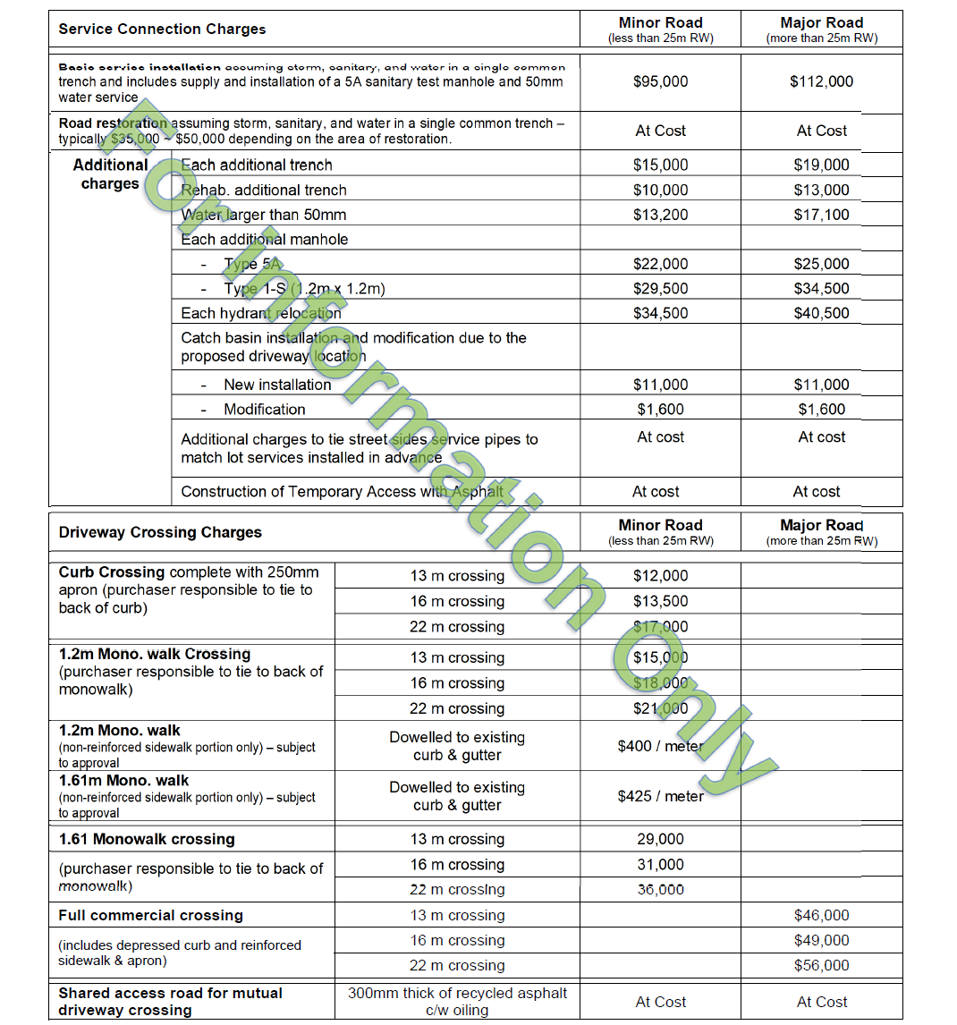
- All charges include a mark up to cover administration, surveying, testing, inspection and maintenance. GST is not included in the above-noted charges and will be added to the final invoice.
- These rates are applied to the current construction season only and assume frost free conditions. Stamped, approved plans that are received after September 01 may have a 25% winter work premium applied. This premium may be applied at the Engineer’s sole discretion against any installation where winter conditions occur at the time of installation. Any construction deferred to a subsequent construction season may also be subject to an increase in the installation rates identified in this Table.
- Should any of the above-referenced work be split into multiple times and/or locations or rescheduled without providing adequate notice to RE&DS, the Purchaser may be required to pay for additional mobilization fees at cost.
- TBD (to be determined) or at cost items shall be added to the final invoice based on actual costs.
- The Purchaser will be solely responsible for the cost of any non-typical service connection arrangement and special admixtures, formwork, extra grading, or other miscellaneous additions that are required in connection with concrete work.

